**The reconciler that isn’t : Whitepaper on leveraging Machine learning for transaction reconciliations.**

**Global Reconciliations POC**

Contents

Overview of Machine learning 3

The problem at hand 3

Need for an integrated/hybrid solution 4

Pieces of the jigsaw 4

Conclusions 5

# Overview of Machine learning

Machine learning as a concept was first formulated as early as in 1959. In the present day, we see plenty of references to this technology in usage. This would range from a simple chat bot with limited range of responses to complex algorithms used by multi national corporations to analyse customer behavior and predict preferences.

Machine learning is an off-shoot of the broader discipline of Artificial intelligence. ML is a study of computer programs/algorithms which can improve autonomously through experience. Such algorithms are capable of drawing conclusions from historic data and deciding further course of action without the need for explicit instructions. In other words , while conventional computer programs follow a predecided sequence of steps as instructed by the programer , ML programs gain intuition from historic actions undertaken.

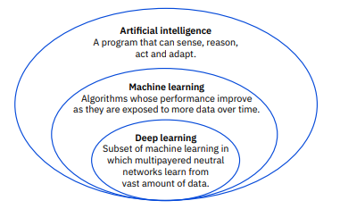

# The problem at hand

Reconciliations team uses TLM as their primary tool to reconcile around 300 million transactions annually. Out of the 300 million, 90% of the transactions are auto-closed by TLM rules defined within TLM’s matching/STP engine. However, this would leave about 30 million transactions to be manually handled by reconcilers.

As is often the case, the problem is with data structure and consistency. Reconciliations’ current version of TLM is highly capable of classifying data based on static and consistent references. Unfortunately, static and consistent reference data is not very commonly available. So, as it turns out, only an experienced reconciler can accurately standardize and decipher such innumerable data references. There is indeed a sizeable group of the mentioned talent available; but surely there skills could be put to better use.

# Need for an integrated/hybrid solution

TLM is the current platform for almost all teams operating within Global Reconciliations umbrella. Immense volume of data is fed into , processed (STP or manually) and reported from this framework. TLM also feeds data to upstream platforms like ELM. Therefore, any solution which does not involve this framework would not be much effective.

# Pieces of the jigsaw

A deep learning model was used over transaction data for 2 years’ time period. As expected the model learned well with minimal loss rate and performed well on test data sets. Yet , we were miles away from operationalizing this model. This kind of a problem needed a complex solution which covers various stages from sourcing live data for prediction to finally making the recommendations visible on each reconciler’s screen; this too within a small time window ensuring no disruption to business.

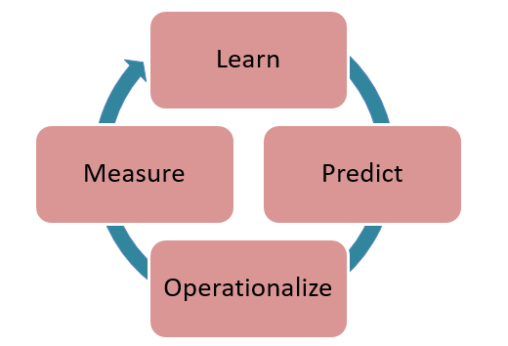

Solution Components :

1. Python based deep learning algorithm
2. Trained/learned ML model for reuse
3. Kubernetes and Docker containers
4. Model orchestration – Argo
5. TLM – model augmentation
   1. Enhanced data flow model
   2. New STP components
6. Review mechanism to measure model decay

# Conclusions

Machine learning is classified as a ‘disruptive technology’. Other members of the same group would be block chain , artificial intelligence or even quantum computing. This is a new age innovation which could change the entire industry quickly and massively. However, for now this technology is in its infancy and would need to be handled with care. Recommendations or predictions provided by these models would continue to need re-affirmation from some real brains.

Having stated the above, I would also add that the though process of adopting this tech as an ally is another absolute necessity. We simply cannot afford to fall short in our quest to timely adapt to technology changes .